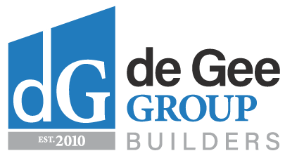

(07) 3204 7525
offic@degeegroup.com ABN: 171 509 202 19

New Enquiry Questionnaire

Name: | Date:
Contact Number:
Address:
Site Address (if different from above):
Type of work required:
Have you been in contact with a draftsperson or an architect? |  | Y N
When do you expect the work to commence? | Date:
If required, have you received council approval? |  | Y N
What is your approximate budget for this project?
It is important for a designer to know your approximate budget prior to working on a project so that together, we can reach the best outcome for all parties involved.
How did you hear about us?
Please ensure that the above information is as accurate as possible and sign below:

De Gee Group may be able to provide a quotation once the above information has been received and assessed, however an hourly rate may be charged depending on the scope of work.

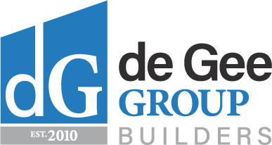
210 Brighton Terrace
Brighton QLD 4017
P: 07 3204 7525

